Database Evaluator Guide

Document history

|  |  |  |  |  |
| --- | --- | --- | --- | --- |
| Version | Date | Author | Changes | Valid from |
| 1.0 | 12-Oct-2016 | Hardik Kansara, Patrick Cura | Edit |  |

Table of Contents

1 Copy the needed files 3

2 Run DatabaseEvaluator.exe 3

3 Browse and select the .dbe 4

4 Generate the PDF Report 6

5 Save the final report 6

6 Verify Report contents 7

# Download the .dbe file

Login to the website as administrator so you can download the .dbe file.

Go to Settings > Select “WordPress File Upload” > Select “View Log”

You can see the all .dbe file on the same page.

Click on “File Browser” tab to download respective file.

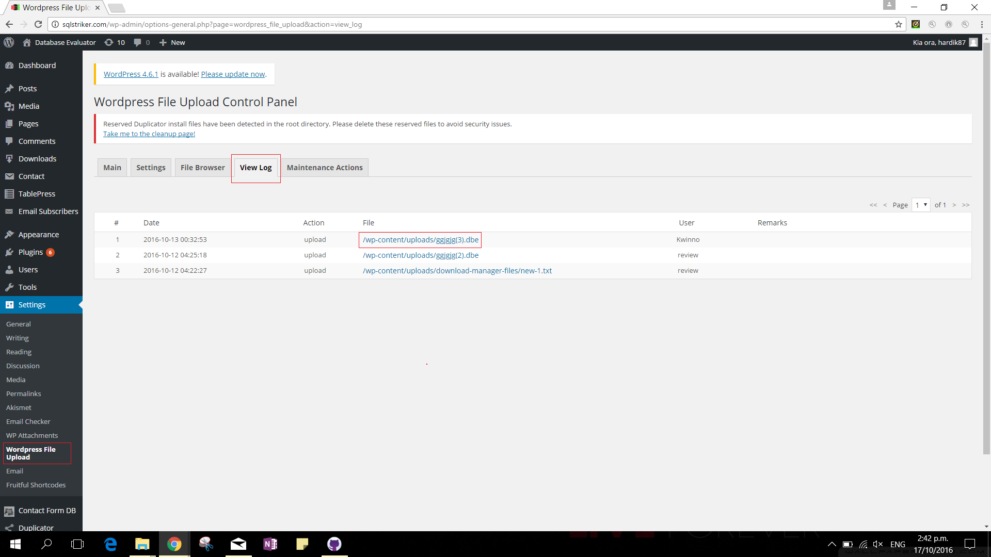

# Copy the needed files

Copy the needed files to run the Database Evaluator.

This includes:

a) itextsharp.dll – The C# library used for creating PDF Reports

b) DatabaseEvaluator.exe – The application developed by the team to produce PDF reports based on the dump file provided by the user

c) FinalEvaluator.sql – The SQL file containing the scripts used in the evaluation proper

d) instance.txt – The text file containing the name of the SQL Server Instance which has all the information needed to do the evaluation

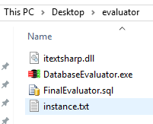

# Run DatabaseEvaluator.exe

Administrator and the evaluator screen should load

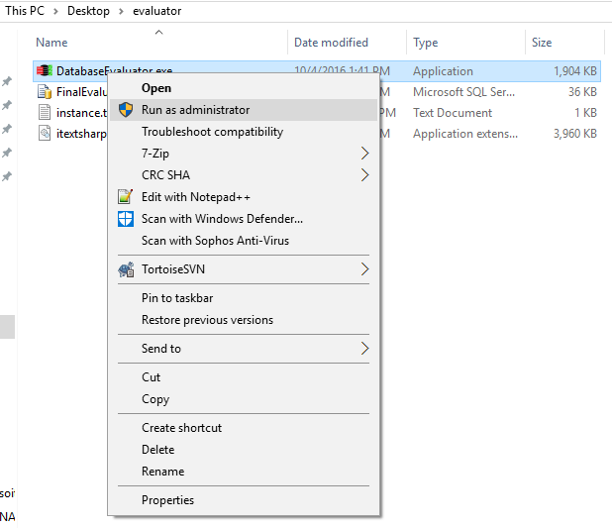

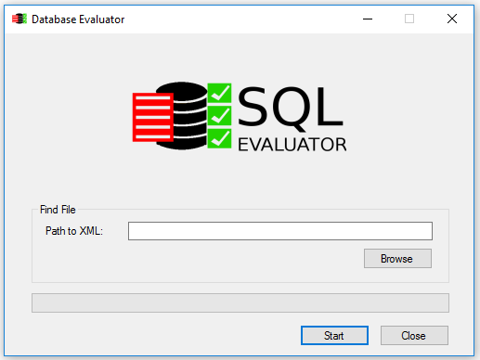

# Browse and select the .dbe

Click on the Browse button and select the .dbe file which contains the SQL Parameters to be evaluated

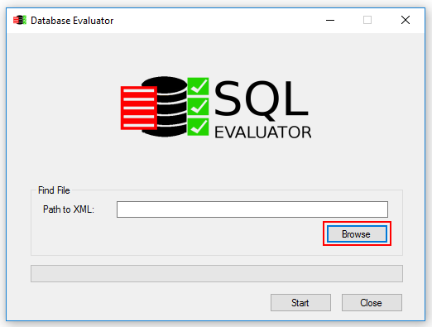

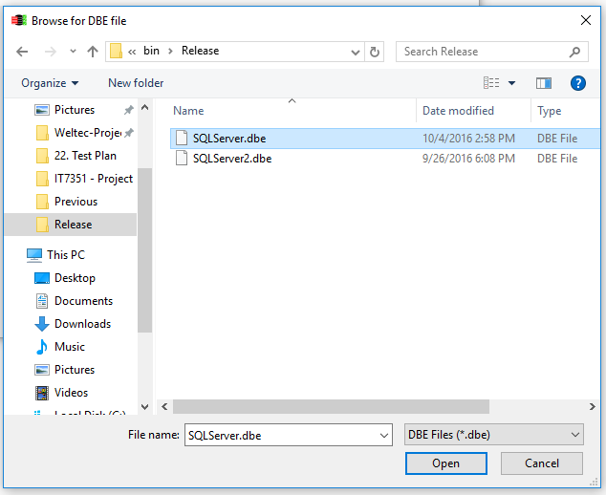

# Generate the PDF Report

The path to the dbe file should now be visible and you can now click on Start to do generate the PDF Report

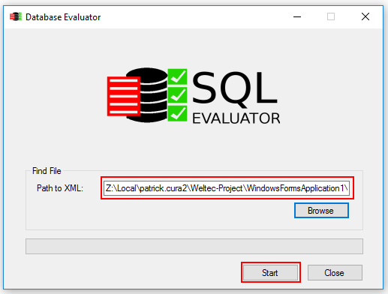

# Save the final report

Once the report is ready, you can now save it

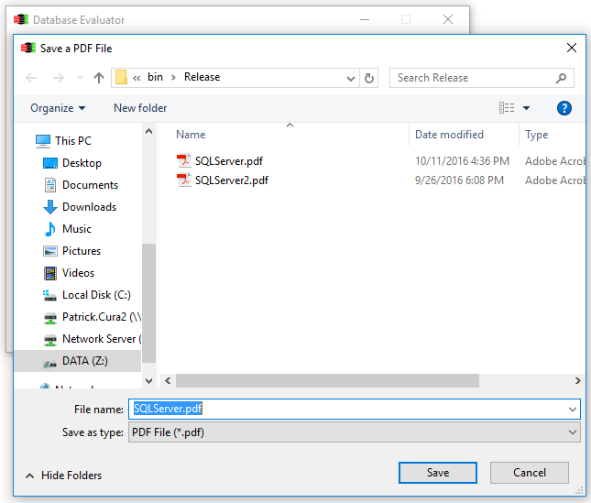

# Verify Report contents

